## **5. Supplementary requirements to road-/ rail and demountable machines**

5.1 Necessary equipotential bonding on an machine that is allowed to work on track with live* overhead contact line

The manufacturer/dealer shall for all machines intended for use on track under live overhead contact line issue a technical drawing that shows all necessary equipotential bonding and its dimensioning, as well as all the other technical measures that is necessary to satisfy the requirements in EN 15746-2, § 5.16.7. Bane NOR assumes to receive a copy of the drawings before BN Materiellkort is issued. The drawing has to have a layout suitable for yearly technical inspection. This applies for all applications for BN Materiellkort October 26th 2016 or later.

*\* live overhead contact line is defined as overhead contact line that has not been disconnected and earthed.*

5.2 Supplementary requirements to 9C machines in order to prevent damage to Bane NOR’s infrastructure

Rail/road machines with rubber belts / wheels which, as a minimum in some operating situations, may come into conflict with the "Forbidden area" in the figure must be equipped with technical functionality so that they can be driven in transported as category 9A and/or 9B (cf. standard EN 15746-1). It may be permitted that machines are lowered down and operate as category 9C locally at the workplace. Actual use as a 9C machine (with rubber wheels / belts running on top of rails) will depend on local assessment in each work assignment.

In the raised position, the rubber wheels must be within the standard forward profile for trains in Norway (i.e. 70 mm above the top of the rail), cf. figure.

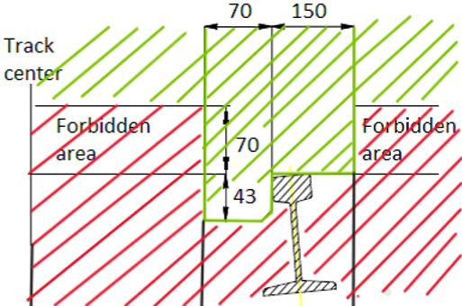

This requirement applies to all machines where application for BN Materiellkort is placed 01/06/2023 or later. It is a clarification of previous requirements introduced on October 26th 2016 that machines had to be equipped with technical functionality for lifting of the rubber wheels.

For machines with very low wheel weight (a few hundred kilos), Bane NOR Transport can consider possibility of a dispensation.

5.3 RCI/RCL (Rated Capacity Indicator / Rated Capacity Limiter)

Bane NOR (Jernbaneverket before January 1st 2017) has from February 22nd 2012 required that all new road-/rail machines shall have RCI/RCL in order to receive BN Materiellkort.

From 04.08.2015 it is decided to stop first time issuing of BN Materiellkort for all vehicles without RCI/RCL which shall have RCI/RCL according to EN 15746-1:2020 § 5.6 and EN 15746-2:2020 § 5.11. This applies to all vehicles independent of when they were first time used on rail in Norway or abroad.

Machines that already have BN Materiellkort / JBV-vognkort or JBV brukstillatelse will have dispensation until further notice. Renewal of BN Materiellkort / JBV-vognkort / JBV brukstillatelse and TKF (teknisk kontrollfrist) for such machines will continue according to standard procedure.

## 5.4 Oransje varsellys på skinne-/vei arbeidsmaskiner

Self-propelled machines must be equipped with at least one orange warning light installed so that it is visible from all directions.

A few smaller blind spots caused by e.g. protruding digging booms or rods can be accepted. It must be mounted sufficiently high above e.g. flat roof so that it is also visible close to the machine.

* 1. Marker lights on demountable and road- / rail trailers (trailers according to EN 15954)

According to EN 15954 (paragraph 5.13):

* trailers can use electrical marker lights on rail.
* shall be equipped with lamp brackets at each end. Instead of electrical lamp Bane NOR accepts use of end of train reflex disc as specified in i TSI OPE paragraph 4.2.2.1.3.2 / Drivers rules book (Førers regelbok) Bane NOR), chapter 8,95 for ordinary freight trains.

As an alternative Bane NOR also accepts use of permanently fixed reflexes in each corner of both ends of the trailer. Each reflex shall have a reflective area of 2 790 mm² or larger. Circular reflexes with diameter 60 mm, triangle reflexes with side edges of 81 mm or quadratic reflexes with side edges of 53 mm are fulfilling the requirement. In case of rectangular reflexes, the area is calculated by multiplying width (mm) x height (mm).

The reflexes shall have read colour. To increase mechanical robustness, the reflexes may be mounted in recesses, but specified reflexive surface shall still be visible from 65° horizontal angle to centre of track on straight track and 30° vertical upward angle. They may also be mounted behind protective grids on condition that the specified reflexive surface is still visible behind the grid and quick cleaning of the reflexes are still possible and not dependent on tools for dismantling the grid.

Reflexes with size and colour according to rules for road use are accepted on road-/rail trailers when used on rail.

* 1. Colour of demountable and road-/rail machines and trailers.

Unless a dispensation is issued for each individual machine,

Bane NOR enforces that demountable and road-/rail machines are acquired and used with a color as specified in:

* EN 15746-1:2020 sec. 5.14.9.1 and 5.14.9.2 (road-/ rail machines).
* EN 15955-1:2013 sec. 5.14.9.1 and 5.14.9.2 (demountable machines).
* EN 15954-1: 2013 sec. 5.13.5.1 (rail/road and demountable trailers).

Questions may be forwarded to: [kjoretoyteknologi@banenor.no](https://banenor-my.sharepoint.com/personal/bjorn_ukkestad_banenor_no/Documents/Dokumenter/Kladd%20juli%2021/kjoretoyteknologi@banenor.no)